**Chapter 1 - introduction**

**The Main Problem:**   
In intensive care units (ICUs), healthcare providers face numerous challenges in effectively monitoring patient vital signs and medical data in real-time.

Traditional methods rely heavily on manual monitoring, where nurses must diligently record vital signs at specific intervals, leading to increased workload and the potential for errors. Moreover, the reliance on paper-based records can hinder communication and coordination between healthcare teams, especially during shift changes, as critical patient information may not be readily accessible.

doctors may find it challenging to leave the ICU for essential activities, such as restroom breaks or consultations, due to the need for continuous monitoring and timely decision-making. This situation can lead to increased stress and fatigue among medical staff and may compromise patient care quality. Therefore, there is a need for a solution that allows healthcare providers to remotely monitor ICU patients without compromising the quality of care.

**Our Solution:**

To address these challenges, we propose the development of an innovative ICU management app called VU. VU aims to streamline the monitoring process, enhance communication between healthcare teams, and improve overall patient care outcomes. By leveraging modern technology and integrating features such as real-time data streaming, automated vital sign monitoring, and electronic record-keeping, VU seeks to revolutionize the way ICU patients are monitored and managed. By enabling remote monitoring capabilities, VU empowers healthcare providers to monitor patients from anywhere, allowing doctors to attend to other essential activities without compromising patient care quality.

**Project Idea:**

The core idea behind VU is to create a user-friendly mobile application that enables healthcare providers to remotely monitor patient vital signs and medical data in real-time. Through the use of advanced hardware components, such as ESP cams, and sophisticated software solutions, including computer vision algorithms and cloud-based databases, VU will provide doctors and nurses with comprehensive access to patient information anytime, anywhere. By automating vital sign recording, improving communication between healthcare teams, and centralizing patient data storage, VU aims to enhance workflow efficiency and patient care delivery in the ICU setting.

**Project Goals:**

Enable real-time monitoring of patient vital signs and medical data through a user-friendly mobile application.

Implement automated vital sign monitoring to reduce manual recording efforts and minimize the risk of errors.

Facilitate seamless communication and collaboration between healthcare teams, including doctors, nurses, and other medical staff.

Provide instant notifications and alerts for critical changes in patient condition to ensure timely intervention and treatment.

Establish a centralized database for storing electronic medical records, enabling easy access and retrieval of patient information during shift changes and emergencies.

Enable doctors to attend to essential activities outside the ICU without compromising patient care quality.

**Project Units:**

**Frontend Application (Flutter App):** Develop the user interface and functionality of the mobile application using Flutter framework, allowing healthcare providers to access patient data, monitor vital signs, and communicate with other team members.

**Backend Server (Spring Boot):** Create the backend server to handle data processing, user authentication, and communication between the frontend application and the database, ensuring smooth operation and data integrity.

**Database Management (MySQL):** Design and manage the database schema to store patient information, medical records, vital sign data, and other relevant data, providing a centralized and secure storage solution.

**Hardware Integration (ESP Cams):** Integrate ESP cams with the system to capture real-time video streams of patient monitors, allowing for remote monitoring of patient vital signs and medical data.

**Computer Vision Algorithms:** Develop and implement computer vision algorithms to analyze video streams and extract vital sign information, such as heart rate, respiratory rate, and oxygen saturation levels, providing automated monitoring capabilities.

**Cloud Services (Firebase):** Utilize cloud services such as Firebase for real-time data synchronization, user authentication, and push notifications, enabling seamless communication and collaboration among healthcare providers.

**Tools and Techniques:**

**For User Interface Design:**

Figma

**For front-end:**

Flutter

Visual studion code

**For back-end:**

Spring boot framework

Intellij idea

**For data base:**

Sql

My sql database management system

**For hardware:**

Arduino ide

Esp32- cam

**For computer vision:**

OCR text detection

**Feasibility Analysis:**

**Technical Feasibility:**

**Hardware Components (ESP cams):** Assess the availability and compatibility of ESP cams in the market. Ensure that the chosen hardware meets the requirements for real-time monitoring and data capture in ICU environments.

**Software Solutions (Computer Vision Algorithms):** Evaluate the technical capabilities of computer vision algorithms for accurate vital sign monitoring. Ensure that the software can handle the complexities of medical data and deliver reliable results.

**Cloud-Based Databases:** Check the scalability, security, and reliability of cloud-based databases. Ensure that they can handle the large volumes of data generated by continuous monitoring in ICU settings.

**Economical Feasibility:**

Pharmaceutical companies can be contracted to display their drugs in app.

**Cost of Development:** Estimate the costs associated with developing the VU application, including software development, hardware acquisition, and integration with existing healthcare systems.

**Return on Investment (ROI):** Assess the potential benefits in terms of increased efficiency, reduced errors, and improved patient care. Determine whether the expected ROI justifies the initial investment.

**Organizational Feasibility:**

**Integration with Existing Systems:** Consider the compatibility of VU with existing hospital information systems and workflows. Evaluate how easily the application can be integrated into the daily routines of healthcare providers.

**Training and Adoption:** Assess the willingness of healthcare professionals to adopt new technology. Develop a training plan to ensure a smooth transition and user acceptance.

**Regulatory Compliance:** Investigate and comply with healthcare regulations and data privacy laws. Ensure that VU meets the necessary standards for medical applications.

**Project Plan:**

|  |  |  |  |  |  |
| --- | --- | --- | --- | --- | --- |
| Task Name | Duration | Start | Finish | Predecessors | job |
| Research and sourcing | 14 days | Sat 9/2/23 | Wed 9/20/23 |  | All team |
| listen from doctors the problem | 4 days | Sun 9/3/23 | Wed 9/6/23 |  | All team |
|  | 5 days | Thu 9/7/23 | Wed 9/13/23 | 2 | All team |
| Collect information about project | 5 days | Thu 9/14/23 | Wed 9/20/23 | 3 | All team |
| Defining requirements | 3 days | Tue 9/12/23 | Thu 9/14/23 |  | Leader |
| Analysis the project | 2 days | Fri 9/15/23 | Mon 9/18/23 | 5 | All team |
| planning | 17 days? | Sat 9/23/23 | Sat 10/14/23 |  | All team |
| system request | 3 days | Sat 9/23/23 | Tue 9/26/23 |  | Analyst |
| feasibly analysis | 8.5 days | Wed 9/27/23 | Sat 10/7/23 | 8 | Analyst |
| project methods | 3 days | Mon 10/9/23 | Wed 10/11/23 | 9 | All team |
| project plan & grant chart | 2.5 days | Thu 10/12/23 | Sat 10/14/23 | 10 | All team |
| Design | 21 days | Thu 10/12/23 | Fri 11/10/23 |  | All team |
| Assigning tasks for each team member. | 4 days | Fri 10/13/23 | Wed 10/18/23 |  | Leader |
| Drawing use case model | 2.5 days | Thu 10/19/23 | Sat 10/21/23 | 13 | Analyst |
| Drawing context diagram and decomposition tree | 6.5 days | Mon 10/23/23 | Tue 10/31/23 | 13,14 | Analyst |
| Drawing dfd diagram | 4 days | Sat 10/21/23 | Wed 10/25/23 | 13 | Analyst |
| Drawing erd diagram And mapping | 2 days | Tue 10/24/23 | Wed 10/25/23 | 13 | Analyst |
| Design (ui,ux) | 8.5 days | Tue 10/31/23 | Fri 11/10/23 | 13,16,17 | UI,UX |
| Implementation | 51 days | Sat 11/11/23 | Fri 1/19/24 |  |  |
| login screens | 6 days | Sat 11/11/23 | Fri 11/17/23 |  | Flutter , UI,UX |
| test authentacion method | 6 days | Mon 11/20/23 | Mon 11/27/23 | 20 | Flutter |
| Test ESP32 modulo taking data | 28.26 days | Sun 11/12/23 | Wed 12/20/23 |  | Hardware dev |
| drawing the relations of factors in database | 11.5 days | Sat 11/11/23 | Sat 11/25/23 |  | Backend |
| Draw the schema of database | 6.2 days | Mon 11/27/23 | Tue 12/5/23 | 23 | Backend |
| implement the computer vision | 16.5 days | Fri 12/22/23 | Sat 1/13/24 | 22 | Computer vision dev |
| Modifies in screens of app | 11.5 days | Sun 12/3/23 | Mon 12/18/23 | 21 | Flutter , UI,UX |
| Modifies in hardware reading data | 11.94 days | Tue 12/5/23 | Thu 12/21/23 | 24 | Hardware |
| test the rest API in app from database | 8.5 days | Fri 12/22/23 | Wed 1/3/24 | 26,27 | Flutter , backend |
| Gating data from ESP to backend server | 6.5 days | Sun 1/7/24 | Mon 1/15/24 | 28 | Hardware ,backend |
| finish all widgets (screens) | 30.64 days | Sun 12/10/23 | Fri 1/19/24 |  | Flutter ,UI,UX |
| Testing | 21 days? | Sat 1/20/24 | Fri 2/16/24 |  |  |
| Testing the whole app | 6.5 days | Sat 1/20/24 | Sat 1/27/24 |  | All team |
| rework some bugs | 6 days | Mon 1/29/24 | Mon 2/5/24 | 32 | Flutter ,backend |
| Modify some feature | 17.75 days | Sat 1/20/24 | Tue 2/13/24 |  | All team |
| chat - to-do list - simple machine learning | 21 days | Sat 1/20/24 | Fri 2/16/24 |  | Flutter , backend ,computer vision |

**System Request:**

**Sponsor:**

Faculty of Computer and Information – Zagazig University.

**Business need:**

The development of the ICU management app stems from the pressing need to modernize and optimize the processes involved in intensive care units. Current methods of patient monitoring and data management are often manual, inefficient, and prone to errors. Moreover, communication between healthcare teams can be fragmented, leading to delays in critical decision-making and potentially compromising patient care quality. The app aims to address these challenges by providing a comprehensive solution for remote patient monitoring, real-time data access, and streamlined communication.

**Business requirement:**

**Improved Patient Care Delivery:** The primary goal of the VU project is to enhance the delivery of patient care in intensive care units (ICUs) by providing healthcare providers with innovative tools and technologies to monitor patient vital signs, streamline communication, and facilitate timely interventions.

**Enhanced Healthcare Collaboration:** The system aims to promote collaboration and teamwork among healthcare professionals by facilitating seamless communication, task management, and information sharing, thereby improving coordination and decision-making in patient care.

**Efficiency and Productivity:** By automating manual processes and providing intuitive interfaces, the VU system seeks to increase operational efficiency and productivity within healthcare facilities, allowing medical staff to focus more on patient care and less on administrative tasks.

**Data-driven Insights and Decision Support:** Through comprehensive data collection and analysis capabilities, the VU system aims to provide healthcare providers with actionable insights and decision support tools to optimize treatment plans, improve outcomes, and personalize patient care.

**Regulatory Compliance and Data Security:** Ensuring compliance with healthcare regulations and standards, as well as maintaining robust data security measures, is paramount to safeguarding patient privacy and confidentiality, as well as maintaining trust in the system.

**User Training and Support:** The successful adoption and utilization of the VU system rely on providing comprehensive user training and ongoing support to healthcare professionals, empowering them to leverage the system effectively in their daily clinical workflows.

**Scalability and Adaptability:** As healthcare needs evolve and technology advances, the VU system should be scalable and adaptable to accommodate future growth, changes in clinical practices, and emerging healthcare trends, ensuring long-term sustainability and relevance.

**Cost-effectiveness and Return on Investment (ROI):** While delivering significant value in terms of improved patient outcomes and operational efficiency, the VU project should also demonstrate cost-effectiveness and a positive ROI for healthcare organizations, aligning with their financial objectives and constraints.

**Customer Satisfaction and Stakeholder Engagement:** Ultimately, the success of the VU project hinges on the satisfaction of its users – both healthcare professionals and patients – as well as active engagement and support from stakeholders, including hospital administrators, IT personnel, and regulatory bodies

**Business value:**

**Improved Operational Efficiency:** Automation of vital sign monitoring and streamlining of processes lead to increased efficiency in ICU operations, allowing medical staff to focus more on patient care rather than administrative tasks.

**Enhanced Communication and Collaboration:** Improved communication between healthcare teams through real-time data sharing and electronic record-keeping fosters collaboration, leading to better coordination and decision-making.

**Empowerment of Healthcare Providers:** Remote monitoring capabilities empower healthcare providers to monitor patients from anywhere, allowing them to attend to essential activities without compromising patient care quality.

**Enhanced Patient Care Delivery:** The overall solution results in enhanced patient care delivery, with timely interventions, improved treatment plans, and personalized care based on real-time data and historical medical records.

**Cost Savings and Resource Optimization:** Automation and optimization of processes lead to cost savings associated with reduced manual labor, improved resource allocation, and optimized bed utilization.

**Compliance and Data Security:** Implementation of electronic record-keeping ensures compliance with healthcare regulations and standards while maintaining robust data security measures, safeguarding patient privacy and confidentiality.

**User Satisfaction and Stakeholder Engagement:** The solutions aim to increase user satisfaction among healthcare professionals and patients by improving workflow efficiency and patient care outcomes. Active engagement and support from stakeholders further contribute to the success of the ICU management system.

**Special issues or constrains:**

**Integration Challenges with Existing Hospital Systems:**

The absence of an established hospital system and database poses integration challenges, potentially delaying the deployment of the ICU management app. Efforts will be required to develop interoperability solutions to seamlessly integrate the app with existing hospital infrastructure and workflows.

**Compliance with Regulatory Standards:**

Compliance with healthcare regulations and standards, such as HIPAA (Health Insurance Portability and Accountability Act) in the United States, poses a constraint on the development and deployment of the app. Ensuring that the app adheres to strict data privacy and security requirements is essential to meet regulatory standards and maintain patient confidentiality.

**Scalability and Adaptability:**

The app must be designed to scale and adapt to varying hospital environments and operational needs. Considerations for scalability, both in terms of user volume and feature expansion, should be incorporated into the design to accommodate future growth and changes in healthcare practices.

**Limited Budget and Resource Allocation:**

Budget constraints and resource limitations may impact the development and implementation of the ICU management app. Effective resource allocation and budget management strategies will be essential to ensure the successful delivery of the project within the allocated budget and timeline.

**Stakeholder Acceptance and Adoption:**

Ensuring stakeholder acceptance and adoption, including healthcare providers, administrators, and patients, is critical for the success of the app. Addressing user concerns, providing adequate training and support, and fostering a culture of acceptance towards digital healthcare solutions are key considerations to overcome potential resistance to change.

**User Flow**

- In the beginning some widgets with panting and tests to explain the power and using of app.

-Entry point: Starting the application either as a doctor or nurser (each one of them have access to different things).

- page to enter your number to authentication with send verifying code OPT to secure that the really doctor or nurse number.

-After sure that is doctor or nurse phone, we check the number in hospital.

Opening home page that contains units each units have the beds numbers in it, and the doctor either the nurse supervisor of.

-Opening the sections of intensive care which navigate you to the beds in each intensive care showing the fall and available beds with patients.

-Showing beds as a card in drop list each card showing name – age – disease – statue of patient – diagram of vital function

Enter any of the bed leads you to page of very specific details of this bed (patient of this bed) his vista functions as details of stating day the patients came to hospital.

-In bottom there are a navigate par to chat with the nurse of this bed and doctor

In top left there are list bar to can show the setting, chat, logout

In top right there are notification which leads to all nomination screen about all patients that’s doctor or nurse care about .

**Functional Requirements:**

**Logging In:**

Users (doctors and nurses) should be able to log in to the system using their registered phone number authentication methods.

- **OTP Verification:** Upon entering their phone numbers, users should receive a one-time password (OTP) via SMS or another method of communication

Monitoring:

- **ٍSee Shift:**

Each doctor and nurse should have access to a personalized view of their assigned shift, displaying the patients and units they are supervising in real time.

- **Care Patients:** Users should be able to access detailed patient profiles, including personal information , Current Vital signs (by streaming) and history , to provide appropriate care.

**- To-Do List:** Doctors should be able to create and manage to-do lists for specific patients, assigning tasks to nurses . And nurse be able to do these tasks.

**Streaming**:

The system should enable doctors and nurses to remotely monitor patient vital signs and medical data in real-time by streaming video from patient monitors.

**Computer Vision Algorithm:**

The system should utilize a computer vision algorithm to analyze video frames from patient monitors, extracting vital signs data such as heart rate, oxygen levels, etc.

**Notification**:

The system should send critical alerts to doctors and nurses regarding any critical changes in a patient's condition, enabling them to provide immediate guidance and support.

**Auto-Insert Vital Signs History:**

The system should automatically insert vital signs data extracted by the CV algorithm into the patient's medical history, creating a comprehensive record over time.

**Non-Functional Requirements:**

**Performance**:

- The overall system latency, including network transmission, data processing, and user interface responsiveness, should be minimized to provide users with a smooth and uninterrupted experience.

- Real-Time Streaming: The system should ensure seamless real-time streaming of video data captured by the ESP cam, with minimal buffering and delays.

- Computer Vision Algorithm:The processing time for the computer vision algorithm should be optimized to ensure timely extraction of vital signs data from the video stream.

- Internet:A reliable network ensures minimal latency and buffering during streaming, allowing doctors and nurses to monitor patient vital signs without delays or interruptions.

High-speed internet ensures that frames captured by the ESP cam are transmitted quickly to the app for processing and display, maintaining real-time monitoring capabilities.

**Reliability**:

- The system should be reliable and available 24/7 to provide continuous service

- The system should have backup and recovery mechanisms to prevent data loss and minimize downtime

- Data Integrity: Patient data stored in the system should be accurate, consistent, and protected against corruption or unauthorized modification.

- Error Handling: The system should provide informative error messages and gracefully handle unexpected errors to prevent system crashes and ensure a seamless user experience.

**Security**:

- Authentication: User authentication should be secure and follow best practices. Users should only have access to data and features appropriate to their roles and permissions.

**Usability**:

- The system should be easy to use and navigate for users of different ages, backgrounds, and abilities .

- The system should have a user-friendly interface that provides clear and concise information to users .

- The system should provide users with guidance and feedback to help them complete tasks efficiently and effectively.

**Scalability**:

- The system should be scalable and able to handle growing demands from users and healthcare organizations.

- The system should be able to accommodate new features and functionalities without compromising performance, reliability, or security .

- The system should use cloud-based infrastructure and technologies to enable flexible and cost effective scaling.

**Interoperability**:

- The system should be interoperable and able to exchange data with other healthcare systems, such as electronic health records (EHRs), medical devices, and telemedicine platforms.

- The system should support different data formats and standards to facilitate data sharing and collaboration among healthcare organizations.

**Project Methodology Option (water fall):**

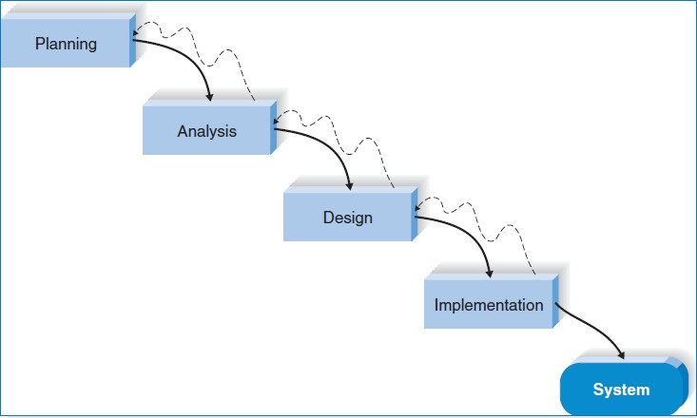

**Business Model:**

|  |  |  |  |  |  |
| --- | --- | --- | --- | --- | --- |
| Key Partners | Key Activities | Value  Propositions | | Customer  Relationships | Customer  Segments |
| Strategic partnerships with hospitals, clinics, and healthcare organizations for pilot testing and deployment.  Collaboration with technology vendors for integration of third-party tools and services.  Partnerships with regulatory bodies and compliance experts to ensure adherence to healthcare regulations. | Software development and continuous improvement of the app's features and functionality.  Customer acquisition and relationship management.  Data security and compliance with healthcare regulations.  Training and support for users to ensure effective utilization of the app | VU offers healthcare providers real-time remote monitoring of patient vital signs and medical data, enabling timely decision-making and improved patient care.  Features include streaming video, computer vision analysis, instant notifications, communication tools, and comprehensive medical record storage.  The app enhances efficiency, reduces errors, and supports better long-term management of patient health | | Customer Support: "VU" offers excellent customer support to address user inquiries and technical issues promptly, ensuring a positive user experience.  Training and Onboarding: Comprehensive training and onboarding resources are provided to help users, including healthcare professionals and patients, effectively utilize the app's features.  Continuous Engagement: "VU" maintains ongoing engagement with customers through various channels to keep them informed about product updates and industry insights.  Feedback Mechanisms: Actively soliciting feedback from users enables "VU" to gather insights and continuously improve the app based on user input.  Personalization: "VU" strives to personalize the user experience by tailoring communication and support services to individual user needs, enhancing overall satisfaction and user retention. | Hospitals and healthcare facilities seeking to modernize ICU management and enhance patient care.  Healthcare providers (doctors, nurses) looking for remote monitoring solutions to improve workflow efficiency. |
| Key Resources | Channels |
| Skilled software developers and engineers for app development and maintenance.  Sales and marketing professionals to drive customer acquisition and retention.  Customer support team to address user inquiries and issues.  Partnerships with healthcare institutions and technology providers. | Marketing and promotional activities targeting healthcare professionals through conferences, seminars, and digital channels.  Direct sales and partnerships with hospitals and healthcare institutions. |
| Cost Structure | | | Revenue Streams | | |
| Development and maintenance costs for the app's software infrastructure.  Marketing and sales expenses for customer acquisition and promotion.  Operational costs, including customer support, server hosting, and data storage.  Regulatory compliance costs related to data security and privacy measures | | | Subscription-based model: Hospitals and healthcare facilities pay a monthly or annual subscription fee based on the number of users and features required.  Freemium model: Basic features are offered for free, with premium features available through in-app purchases or subscription upgrades.  Licensing fees for customizations and enterprise-level deployments | | |

**Use Case**

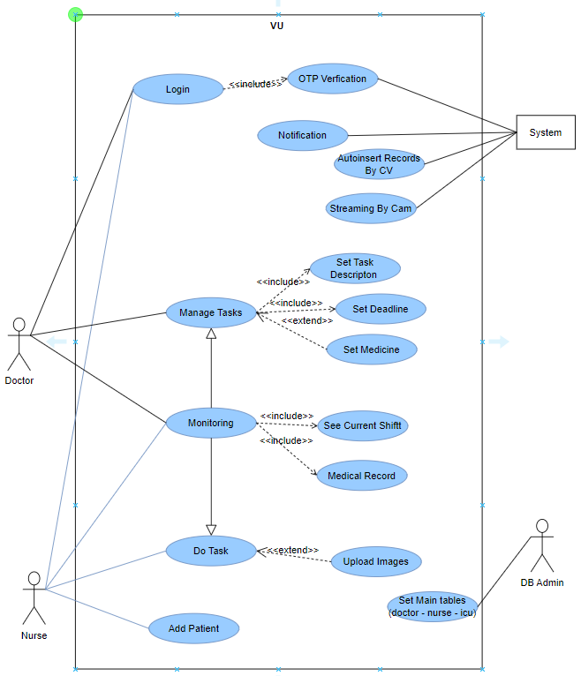

**Use Case Tables**

**Use case name:** Login.

**Actor:** Doctor , Nurse.

**Id:** 1

**Priority:** High

**Description:** The actor choose his role either doctor or nurse , and enter his phone number that must be exist in DB , verification happened by sending verification code through firebase authentication , and the actor set his profile picture.

**Trigger:** The doctor or nurse set his information in order to login the app.

## Type:

external

temporal

**Precondition:** Enter his info , do the verification and set the profile picture.

## Normal course:

* Actor set his role.
* Actor enter his phone number
* Actor set profile picture

## Information Steps:

Database Authentication

* + Doctor’s section

**Post condition:** Actor login the app

**Exception:** Actor entered wrong data.

**Input:** role , phone number

## Source:

Doctor , Nurse

**Output:** login the account

## Destination:

Database of the system

**Use case name:** Monitoring

**Actor:** Doctor , nurse.

**Id:** 2

**Priority:** High

**Description:** The doctors see their daily shifts , units they are responsible for ; Nurses see their shifts which is hourly based and patients they are responsible for.

**Trigger:** Doctors need to know their shifts schedule and the units or patients hey are responsible for .

**Type:** external temporal

**Precondition:** Doctor or nurse login the app.

## Normal course:

* Doctor or nurse login to the application.
* Doctor or nurse request their shifts infromation.

## Information Steps:

* + Application data base.
  + Confirmation.

**Post condition:** Doctor and nurse know their shifts schedule , responsibilities.

**Exception:** Doctor or nurse were not able to login.

**Input:** Doctor or nurse information.

## Source:

Admin.

**Output:** Shift information.

## Destination:

Database.

**Use case name:** vital signs record

**Id:** 3

**Priority:** High

**Description:** Record the vital signs for the patient

**Type:** external temporal

**Precondition:** The vital signs are sent to the database.

**Post condition:** got the records for every patient

**Exception:** patient data is incorrect

**Input:** patient records

## Source:

Patient records

## Output:

records

## Destination:

Database

**Use case name:** OCR

**Id:** 4

**Priority:** High.

**Description:** OCR is used to extract vital signs records from frames.

**Type:** external temporal

**Precondition:** Camera is positioned towards patient records.

**Post condition:** The vital signs for the patient is stored in the database

**Exception:** The position for taken photo is incorrect

## Input:

frames

## Source:

cam.

## Output:

Patient vital signs.

## Destination:

Database.

**Use case name:** streaming by cam

**Id:** 5

**Priority:** High

**Actor:** Doctor , nurse.

**Description:** Cam is positioned towards the patient vital records to take frames

**Type:** external temporal

**Precondition:** doctor add the name of medicine and its time

**Post condition:** Frames are stored into database.

**Exception:** Cam is positioned in wrong position.

## Input:

Frames

## Source:

Esp cam

## Output:

Records

**Destination:** Database

**Use case name:** To do List

**Id:** 6

**Priority:** High

**Actor:** Doctor , Nurse.

**Description:** Doctor and nurses can make a to do list for their jobs and responsibilities.

**Trigger:** doctor do that in order to manage their time and focus on their tasks without interruption.

**Type:** external temporal

**Precondition:** Doctor and nurses put their task.

**Post condition :** A to do task is made for every doctor and patient.

**Exception:** patient need to book again

Input: Tasks

## Source:

Doctor , Nurse

## Output:

To do list

**Destination:** Database

**Use case name:** Database administration.

**Id:** 8

**Priority:** High

**Actor:** Admin.

**Description:** Database for equipments , units , doctors , nurses.

**Trigger:** that make admin know everything about the hospital components

**Type:** external temporal

**Precondition:** Admin insert data about everything in the hospital

**Post condition:** Admin will know everything about the hospital

**Exception:** if doctor didn’t do that he will not know what happened and what he will do

## Input:

Data of the hospital

## Source:

Admin

## Output:

Database

## Destination:

Admin

**Activity Diagram**

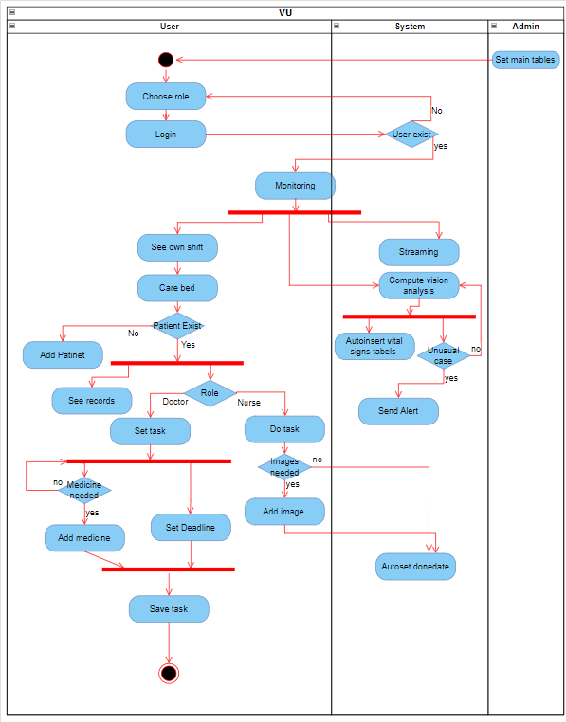

**Sequence Diagram**

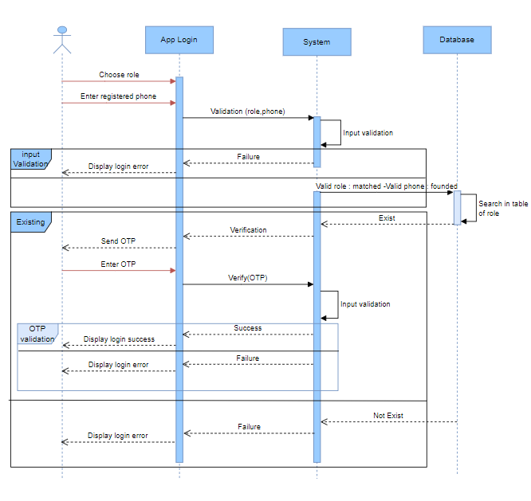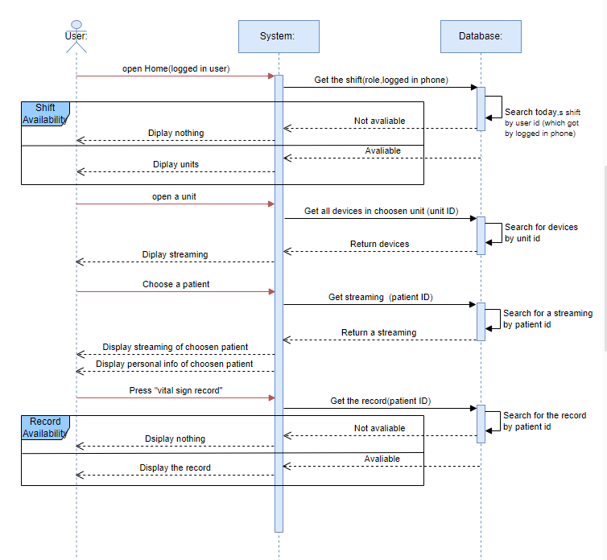

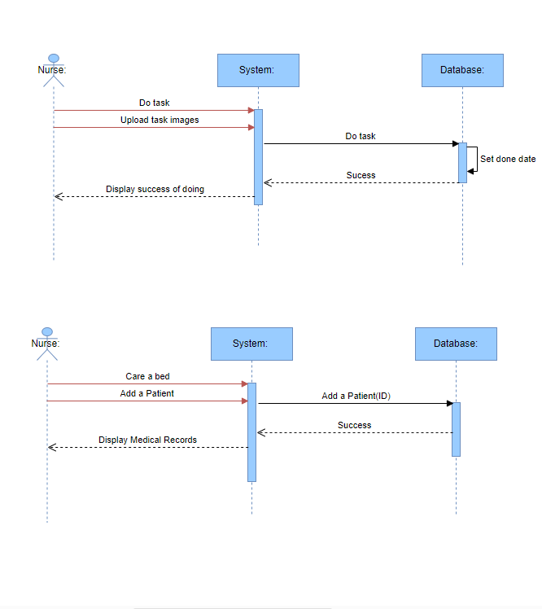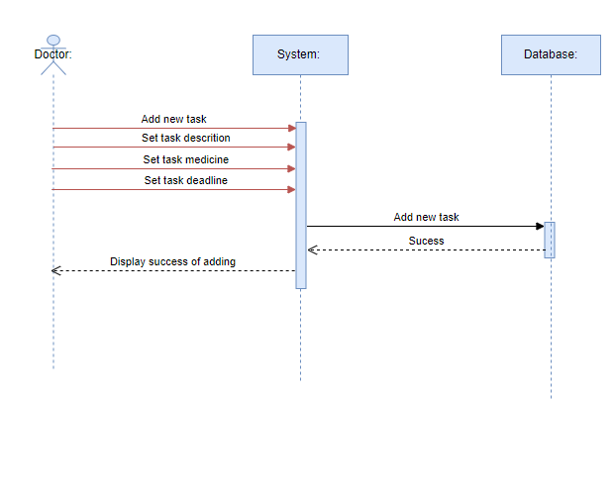

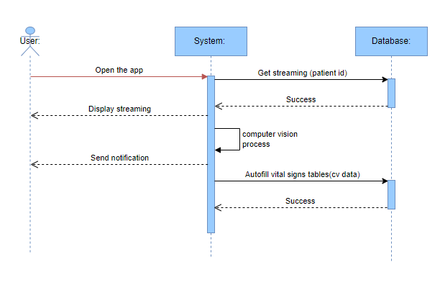

**Collaboration Diagram**

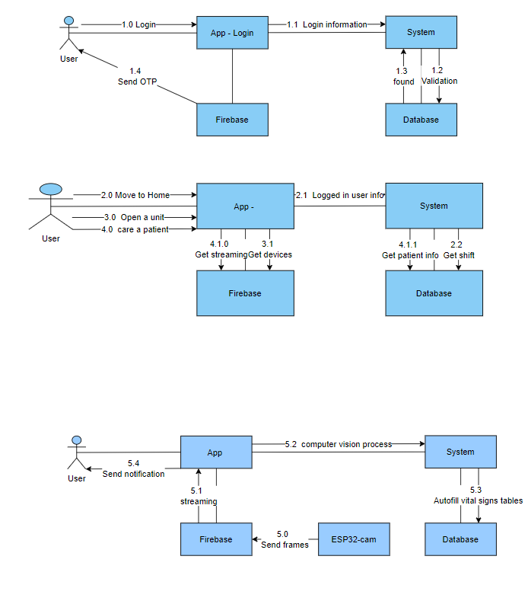

**Deployment Diagram**

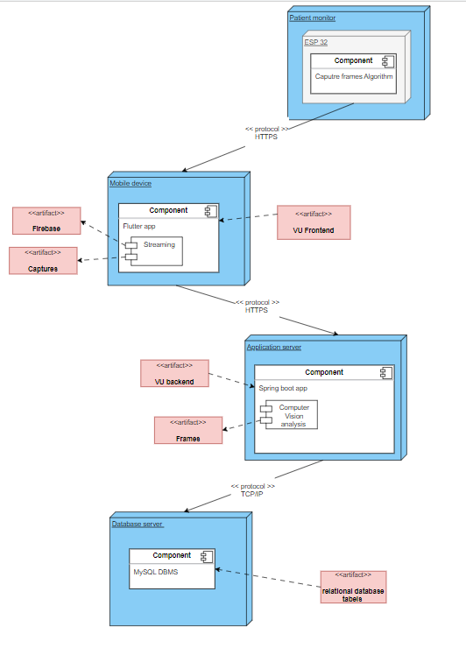

**Component Diagram**

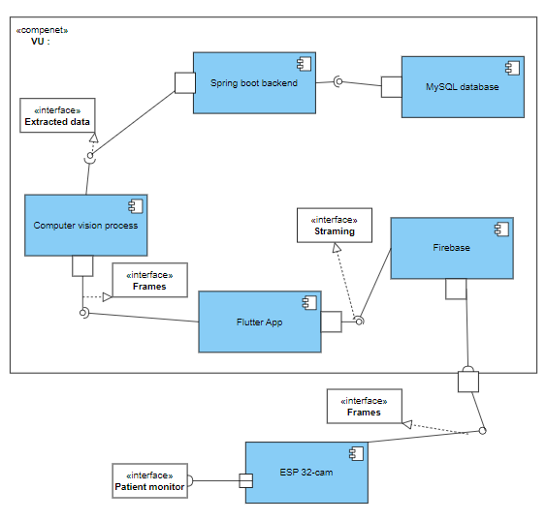

**Context Diagram**

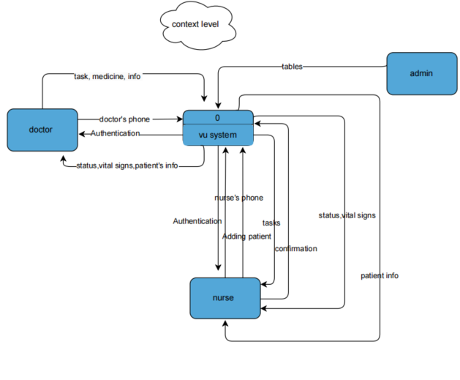

**Level 0**

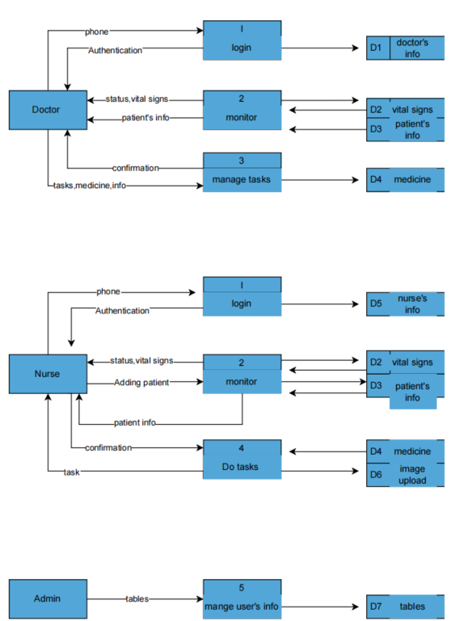

**ER Logical Diagram**

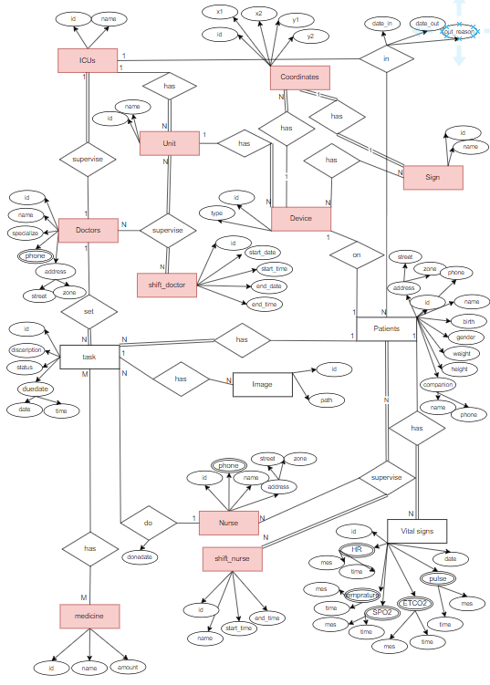

**ER Physical Diagram**

